**Lab 0 RISCV Emulation Part 1**

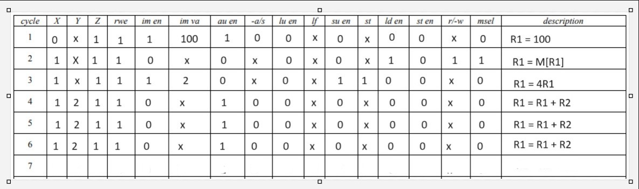Microcode